How to create a Playlist
Remember that you need to ingest content into your program library using a separate process before you open DAD prep.
Open the relevant content in Adobe audition. Check that you have the correct file. Check the audio quality and ensure that the recording has reasonably consistent levels normalised to 90% or -1dB. (0dBFS is the maximum amplitude (loudness) before the audio becomes distorted)*. Ensure there is no silence at the end or beginning. Ensure it is in correct format: wav, 44100 Hz, 16 bit, mono for voice only, stereo for music or music and voice.
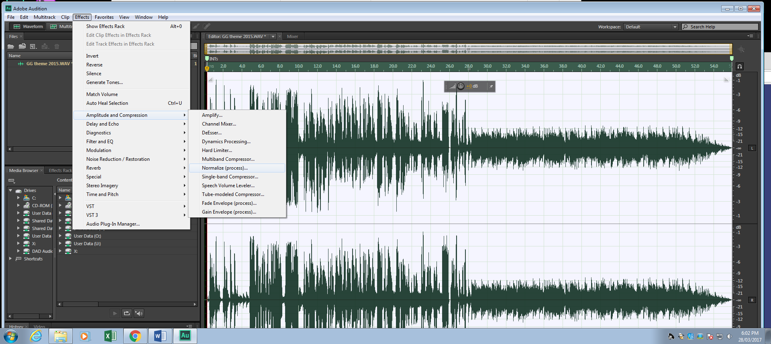

SAVE the file into the DAD drop box.
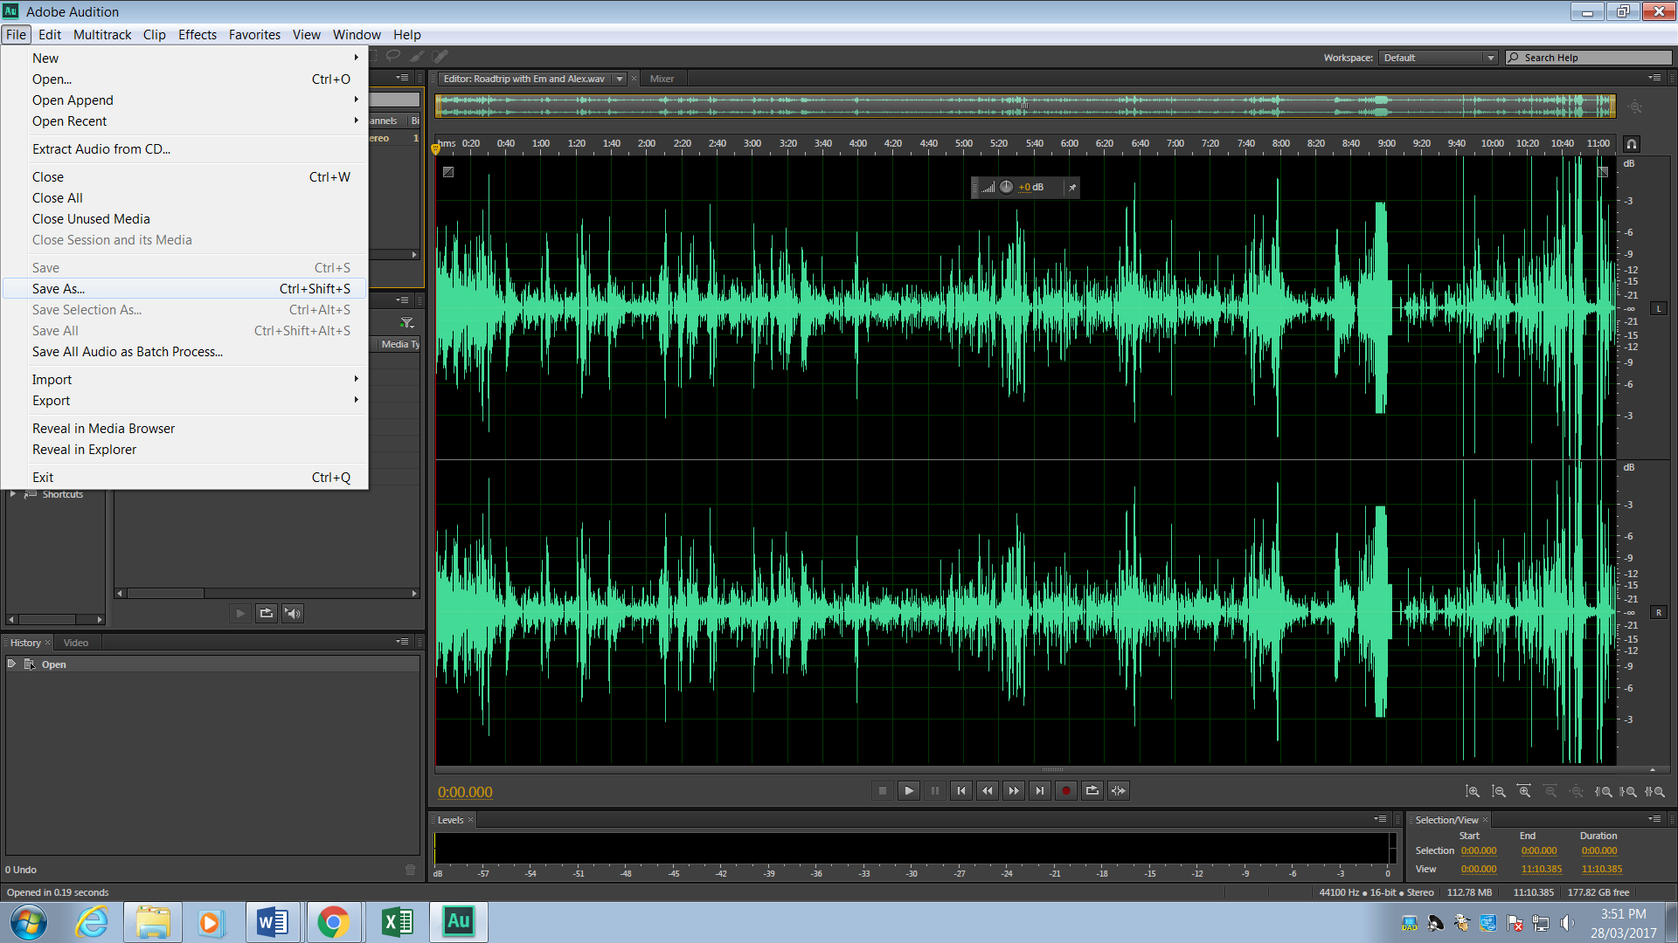
Do not drag and drop the file into DAD. You want to create a unique copy for DAD because DAD is not a storage folder. It is a playout system. Cuts (audio files) are set to delete after two weeks unless you change the USER DEF to Keep within the DAD library. To save to DAD use the browse box. Select #DAD-IN-PROGRAM_NAME on your U Drive

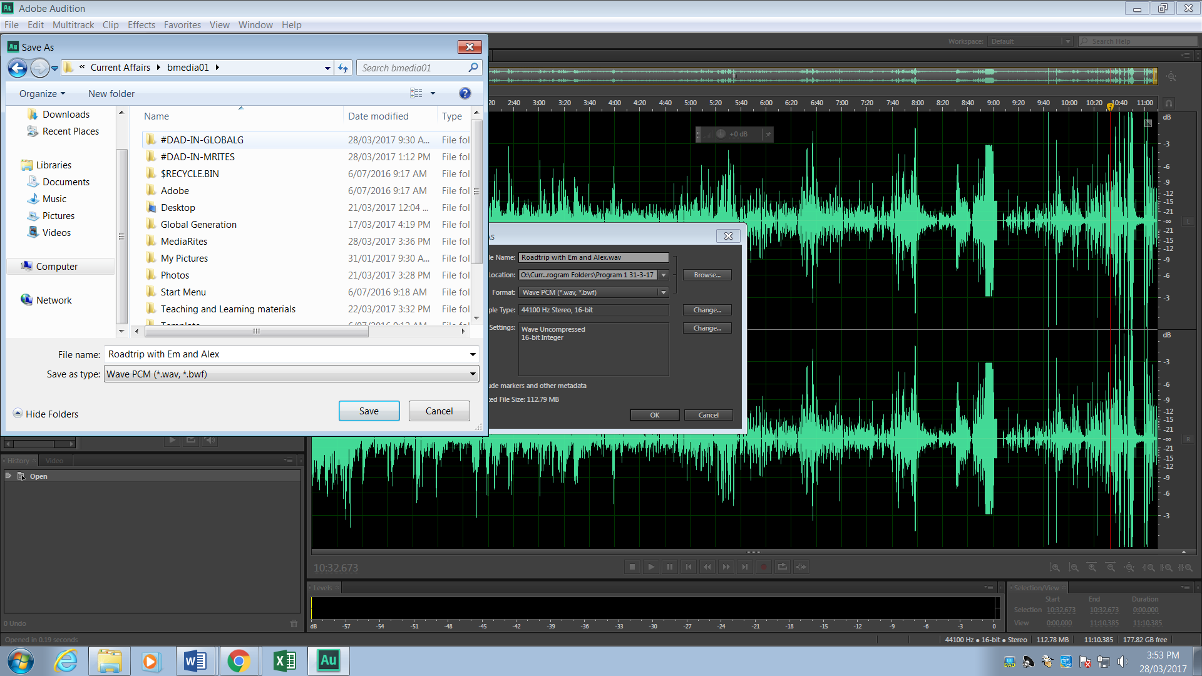
Hit OK. The file will be ingested to DAD. It’s like a cosmic portal. You can’t retrieve it from the Drop box.
So, now it’s in the library. Let’s make the playlist!
Playlists are programmed to auto load in the on air studio at 1 minute to the hour. This is the playlist which you need to amend and overwrite for every show. Do not create another playlist, with a different name – it will not auto load or BRANCH to the next program.
How to load and amend the playlist in DAD prep.
Open DAD Studio and select your program
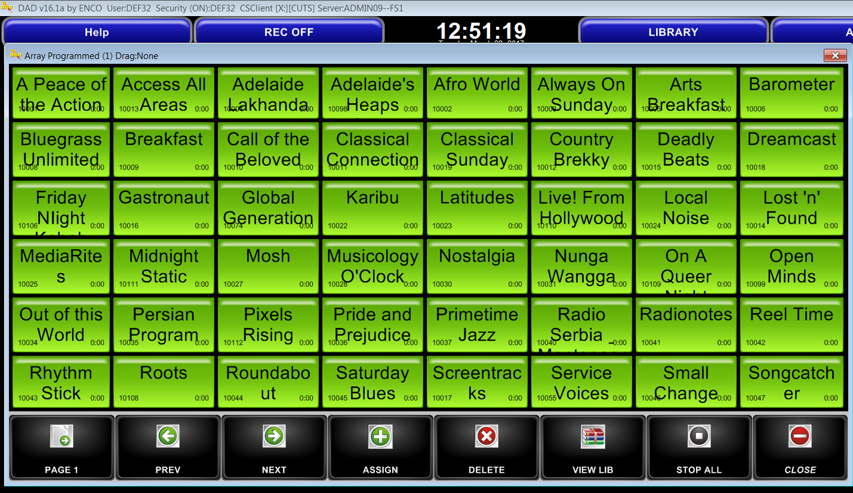

The program library will open. Hit the blue PLAYLIST tab
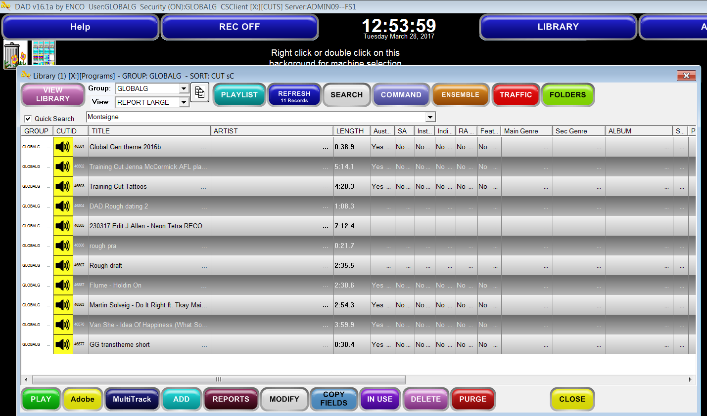
Then hit the Grey PLAYLIST tab

Select a playlist.
This playlist should be overwritten every week. It will auto-load in the on air studio and will BRANCH to the next scheduled Radio Adelaide program at the end of your program.
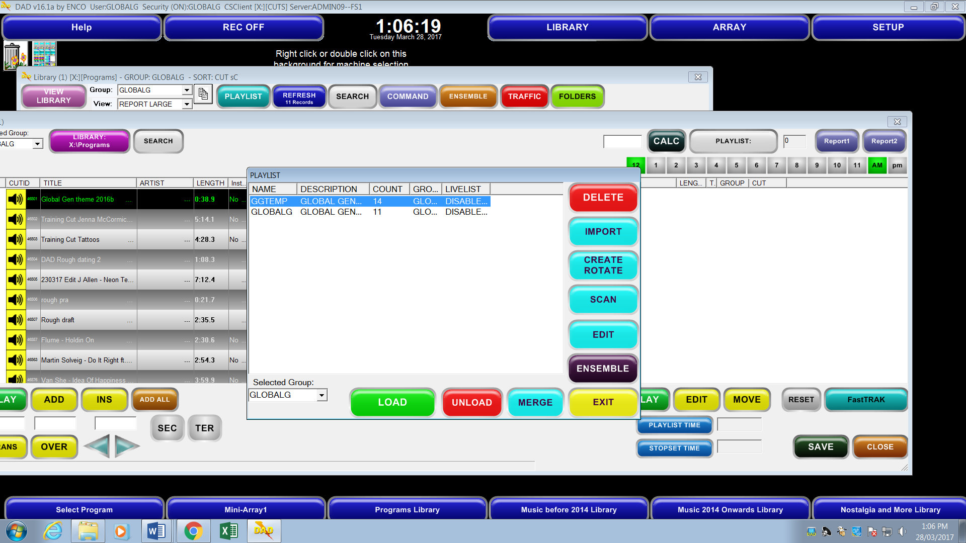
Your playlist will load. You can drag content from your program library into the playlist. You can delete old audio content shown with a speaker icon 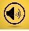. Do not delete anything above the top red line or below the bottom red line. Do not delete anything with a black i or labelled Branch or Chain.

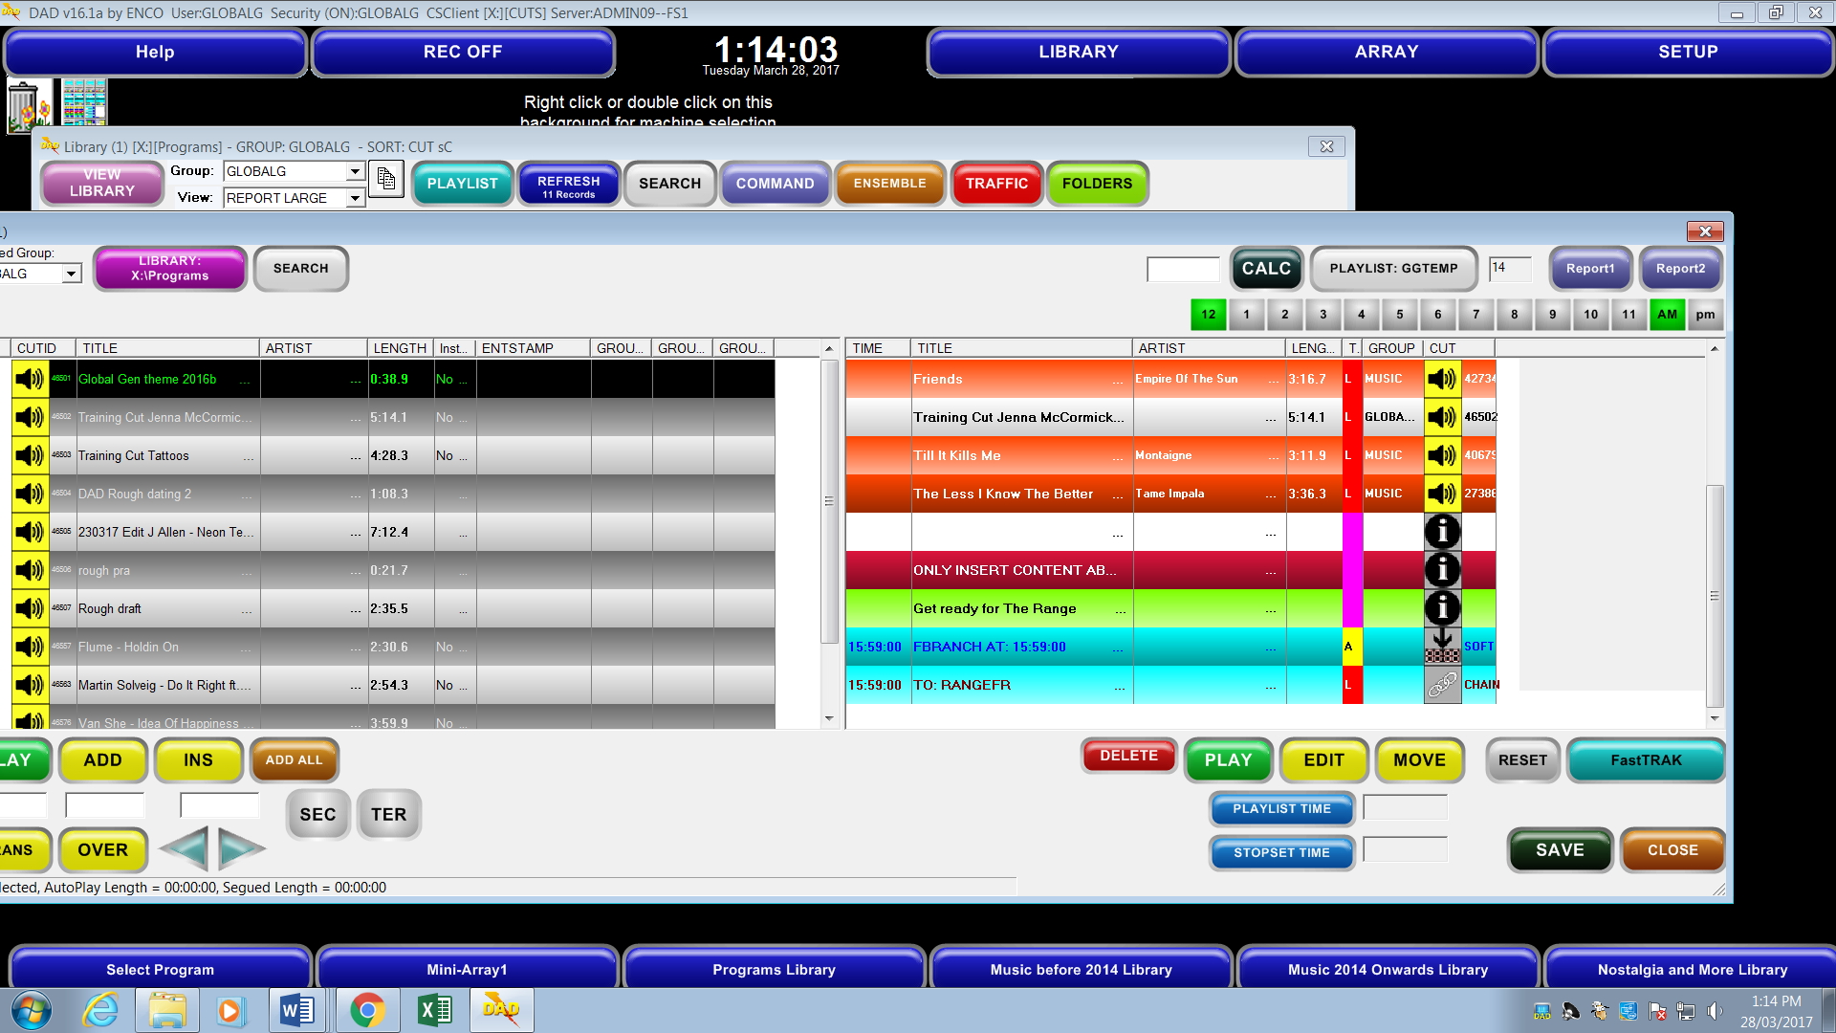

You can open the Music library using the blue tab at the bottom of the screen. Enter the name of the track or band in the search bar. Drag a track to the playlist. If the playlist isn’t visible, hit Select Program tab and hit your program name and playlist tabs again – as explained above.

When you’ve created your playlist, check that the audio plays with the green PLAY tab. Check the duration of each CUT/ Title. If you want to calculate the total time of all the items, hit the blue PLAYLIST TIME tab at the bottom.
Hit the black SAVE tab.

Then - Hit the aqua SAVE tab in the small box that appears

Yes, Hit OK to overwrite.
You have saved the playlist and can now open it in a studio with DAD STUDIO.

Re: Normalisation and optimal levels. There’s a lot of debate about this subject in the industry.
*dB = decibel - the unit of measurement for ‘loudness’. TV tends to use -9 or -12. Radio can vary between -6dB and -12dB. The online environment tends to favour 0dB or -1dB. I’ve chosen -1dB so that your audio peaks no higher than -1dB and most of the audio will be lower (unless you use a peak limiter and compression but if you’re a dynamic purist – you don’t want too much of that). It also ensures that the audio is at the right level for the website when we upload it as a story. The most important thing is that we all normalise to the same level and monitor the levels in the studio when going to air so that we get a good consistent sound for the whole program. We don’t want soft mics, loud music tracks and recorded audio that is all over the place.

