How to use Studio 3

Step 1:
Make sure the computer for your station is turned on and both monitors are on

Step 2:
Make sure the monitor/keyboard/mouse are set to your computer
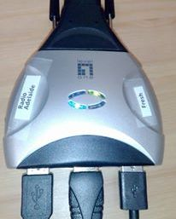

Press the small black
button on the side

Step 3:
Configure the desk for our station
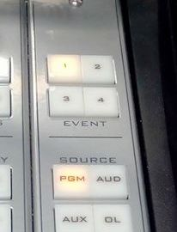

Radio Adelaide is 1 or 2

Fresh is 3 or 4

Make sure all channels are off first then…
- Press and hold button 1 or 2 for 3 seconds until it lights up
- Then release and tap again quickly. (You should see the panel channel labels change to Radio Adelaide’s set up)

*For Radio Adelaide:
If the computer is not on before this step the computer and DAD channels will not show on the desk

